# Sales Performance Analysis Report

## **Overview**

This project involves end-to-end analysis of a global retail dataset, focusing on sales and profitability patterns across different time periods, regions, product categories, and customer segments. The primary objective was to transform raw sales data into meaningful insights and interactive dashboards for business decision-making.

## **Data Set Used**

The dataset used for this project is the **Superstore Dataset (Final)** available on Kaggle, sourced from:  
 <https://www.kaggle.com/datasets/vivek468/superstore-dataset-final>

This dataset contains detailed retail sales data for a global superstore, covering the period from **2014 to 2017**. It features various dimensions relevant to business analytics and performance evaluation.

## **Tools Used**

This project involved multiple stages of data processing, analysis, and visualization, utilizing a combination of tools:

* **MySQL (via DBeaver):** Used extensively for querying, cleaning, and transforming the sales dataset.
* **Microsoft Excel:** Employed for preliminary data inspection, handling missing values, formatting issues, and exporting structured tables. Also used for data preparation prior to visual analysis.
* **Tableau :** Used to build insightful and interactive dashboards. Various visualizations like bar charts, line graphs, maps, and filters were created to showcase trends, customer segments, and product performance.
* **Kaggle:** The dataset was sourced from Kaggle, which provided a comprehensive

## **Project Objectives**

* **Understanding Sales & Profit Trends:** Analyze how sales and profit vary across different years, months, regions, and product categories.
* **Customer & Product Insights:** Identify the most profitable products and high-value customer segments to inform targeted business strategies.
* **Geographic Performance:** Examine performance across different states and countries to highlight strong and underperforming markets.
* **Building Interactive Dashboards:** Create clear, dynamic visualizations using Tableau that can help stakeholders interact with and interpret the data effectively.
* **Supporting Business Decisions:** Translate the data into practical recommendations that can help optimize product focus, regional strategy, and customer engagement.

## **Data Preparation & Cleaning**

The dataset from Kaggle was imported into MySQL, Excel, and Tableau for analysis. Key preparation steps included:

* **Date Formatting:** Order Date and Ship Date were converted from string to proper date formats using SQL functions like STR_TO_DATE, enabling time-based grouping.
* **Handling Missing & Duplicate Data:** Null values in key fields (like Profit, Sales) were addressed, and duplicates were removed to maintain data quality.
* **Data Type Corrections:** Numeric columns such as Sales, Profit, and Discount were verified and converted to appropriate types (e.g., DOUBLE) to support accurate calculations.
* **Column Renaming:** Column names were standardized using aliases and formatting for easier querying and visualization.

This preparation ensured clean, reliable data for meaningful insights.

## **Analysis & Insights**

The EDA phase focused on understanding key patterns and relationships in the sales data using SQL queries, Excel summaries, and Tableau visualizations. Key analyses included:

* Yearly Sales Trend

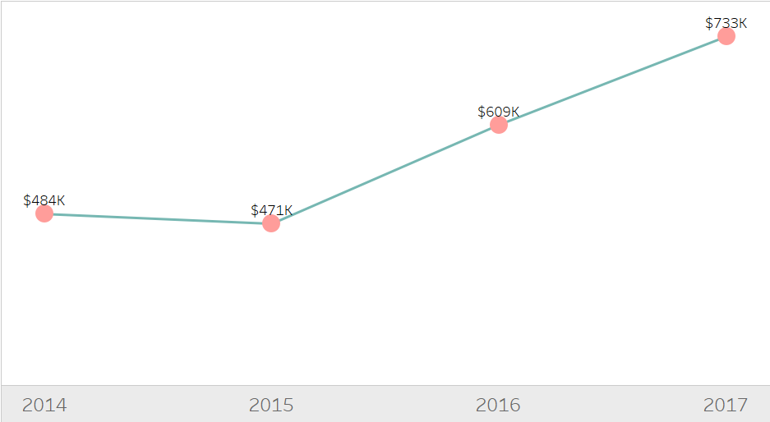

From 2014 to 2017, the company experienced consistent growth in annual sales, reaching a peak of **$733K in 2017** — the highest on record.**Given this trend, it's reasonable to expect continued growth in future years**, assuming current business conditions remain stable.

* Monthly Sales Trend

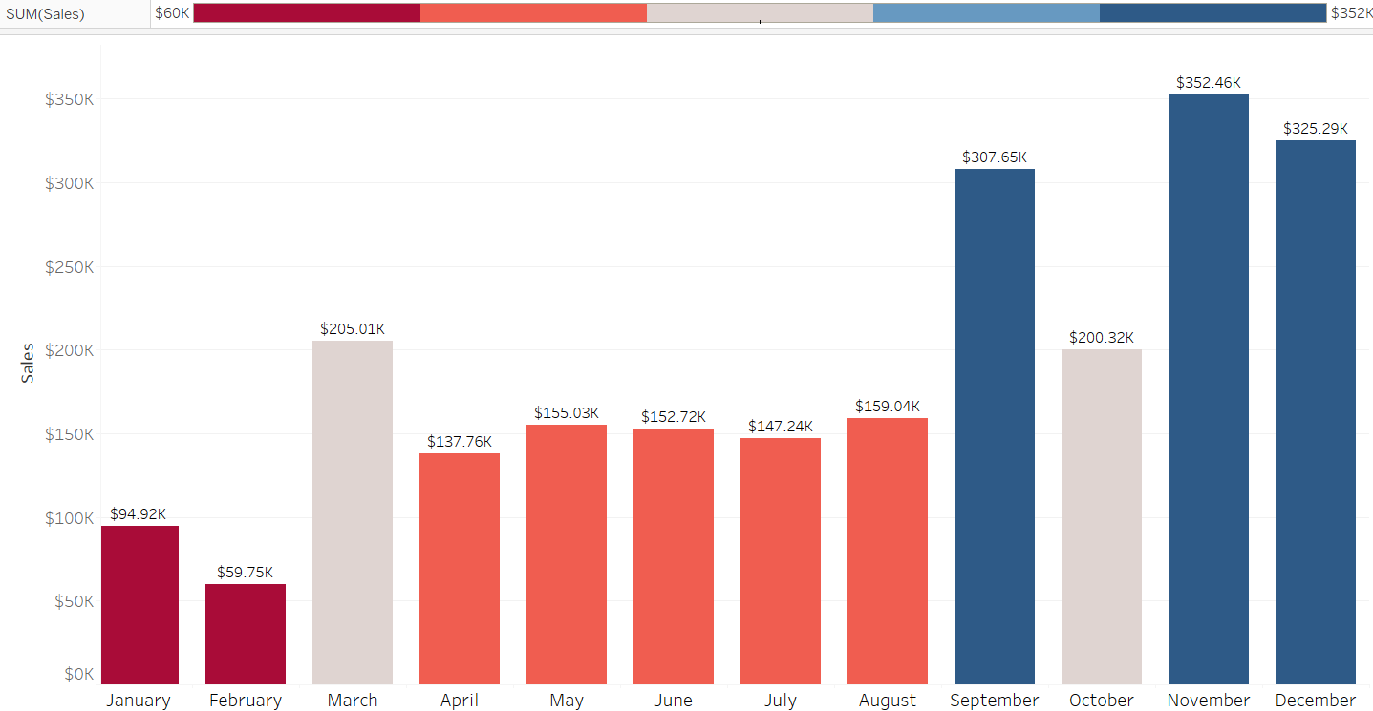

The company experienced its highest sales at the end of the year, with November and December showing peak performance. In contrast, the lowest sales were recorded during the early months of January and February.

* Product Analysis

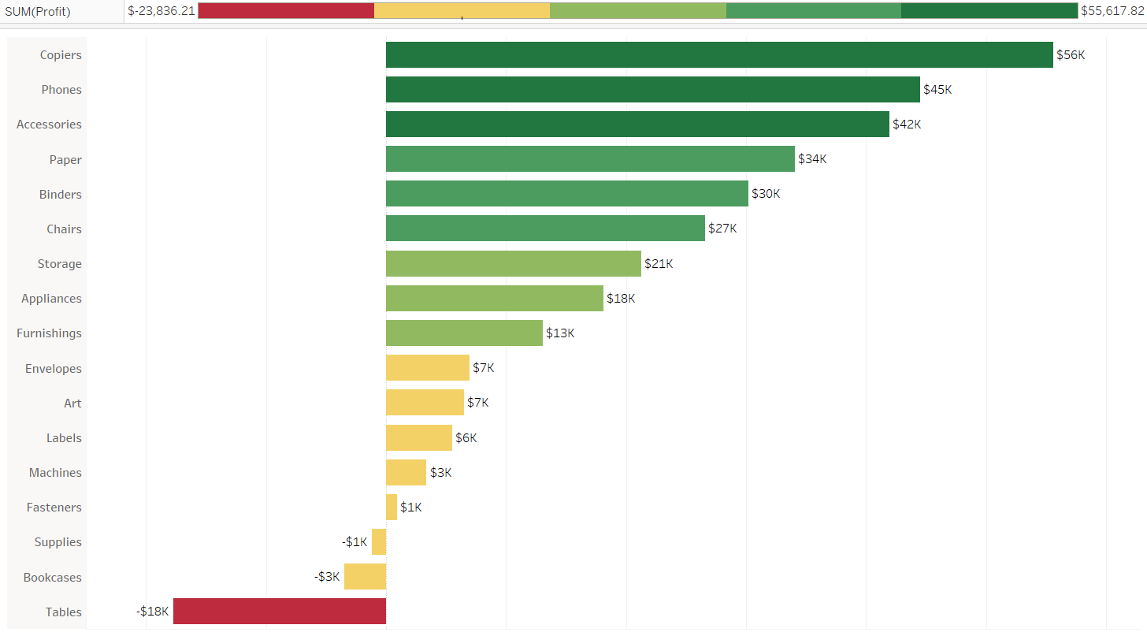

Technology products like Copiers, Phones, and Accessories drive the most profit, while Furniture items such as Tables and Bookcases perform the worst.

Best Performers of 2017

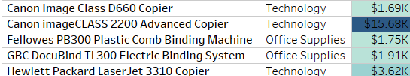

Worst Performers of 2017

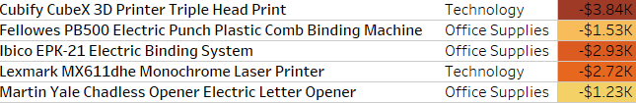

* Profit Across Regions

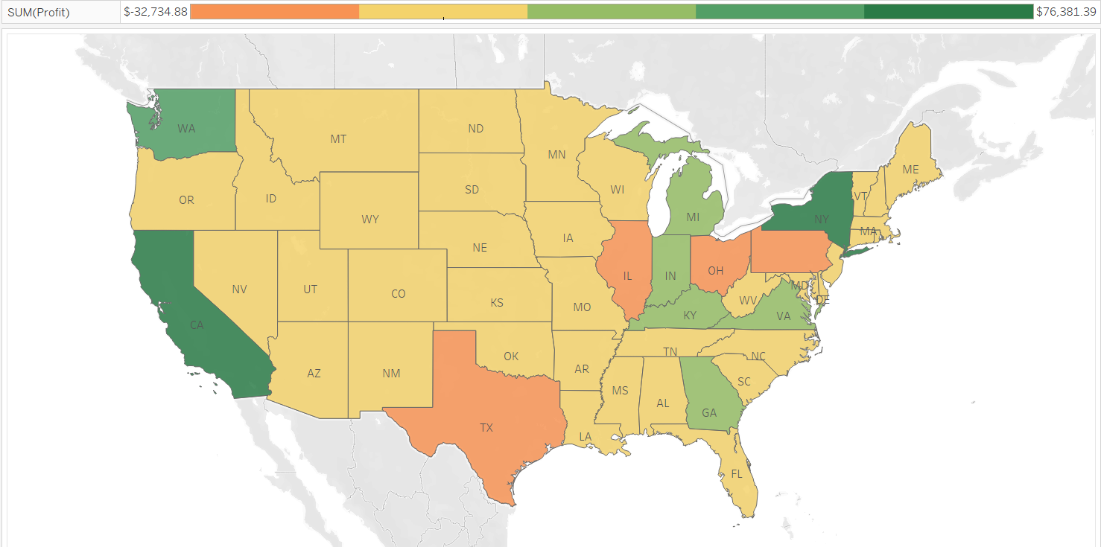

**California** and **New York** are the top profit-generating states. Meanwhile, **Texas**, **Illinois**, **Ohio**, and **Pennsylvania** are the only states that consistently recorded losses over the four-year period. These states require closer analysis and potentially strategic intervention.

## **Dashboard & Visualization**

👉 [**Sales Analysis Dashboard**](https://public.tableau.com/app/profile/adwaith.chandran/viz/SalesDataDashboardFinal/SalesAnalysisDashboard)

This dashboard displays monthly sales trends, top-performing categories, and state-wise profit distribution using color-coded visuals.

These Interactive dashboards were created using **Tableau** to present the findings from the analysis in a clear and engaging format. The dashboards aimed to provide stakeholders with an intuitive view of the business performance.

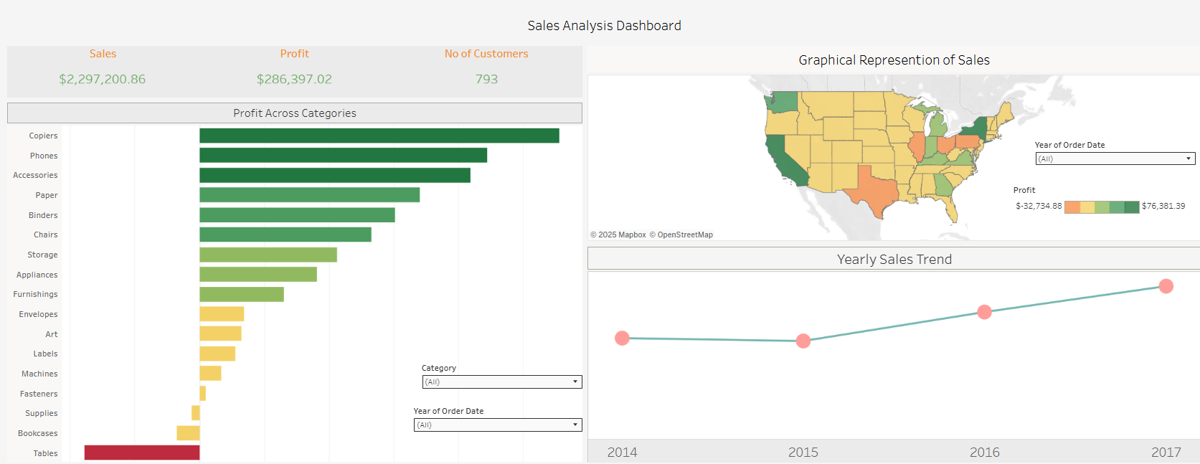

Key visualizations included:

* **Sales & Profit Over Time:** Line and bar charts showing trends by year and month.
* **Top Products and Categories:** Highlighting the most profitable product segments.
* **State-wise Performance Map:** A filled map showcasing geographic variations in sales and profit.
* **Customer Distribution:** Visuals to explore customer count across different regions and time periods.
* **Profit vs. Discount Scatter Plot:** Illustrating the relationship between discounts and profitability.

Each dashboard incorporated filters for interactivity (e.g., by year, category, or region), enabling dynamic exploration of the data. The goal was to support data-driven decision-making through accessible and insightful visual tools.

## **Conclusion**

The analysis of the Superstore sales data from 2014 to 2017 provided valuable insights into product performance, customer behavior, and regional profitability. Overall, the company experienced steady sales growth, reaching its highest recorded sales in 2017. The **Technology** category stood out as the most profitable, while the **Furniture** category, particularly Tables and Bookcases, consistently underperformed.

Geographically, states like **California** and **New York** contributed significantly to overall profit, whereas **Texas**, **Illinois**, **Ohio**, and **Pennsylvania** showed recurring losses throughout the four-year period. The correlation analysis also indicated that **higher discounts negatively impacted profits**, especially in certain segments.

The visual dashboards developed using Tableau enabled intuitive exploration of these patterns and trends, making it easier for stakeholders to interpret complex data and identify actionable opportunities.

## **Recommendations**

* **Prioritize High-Margin Products:** Focus on marketing and stocking top-performing technology items like Copiers and Phones, which consistently drive profit.
* **Optimize Discount Strategy:** Minimize excessive discounting, particularly in the Furniture segment, where high discounts are not translating to profit.
* **Address Underperforming Regions:** Investigate and reassess strategies in loss-making states like Texas, Illinois, and Ohio—this could involve revising delivery costs, inventory strategies, or customer targeting.
* **Leverage Seasonal Trends:** Increase promotional efforts in Q4 (November and December), which show the highest sales activity.
* **Build on Customer Insights:** Target loyal or high-spending customer segments with tailored offers, especially in profitable product categories.